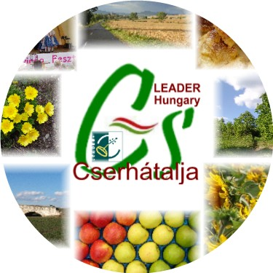 | Cserhátalja LEADER Helyi Akciócsoport Cserhatalja LEADER LAG

INVITATION
European LEADER Cooperation Forum and Rural Tourism Festival, Kozard, Hungary

On behalf of LAG Cserhatalja, we are pleased to invite you to the European LEADER Cooperation Forum.

What: 2nd European LEADER Cooperation Forum in Kozard, Hungary
When: 16-18 September 2010
Where: Cserhatalja LEADER LAG, Kozard, Hungary
Working language: English
Agreed projects’ meeting: 16 September
Forum and Networking: 17 September (09-12h) and 18 September (Festival)
Rural Festival: 18 September

Programme

Day 0: Thursday 16 September
- Arrival of agreed project partners.
  - Optional 1: Pre-Organized visits to partner LAGs in North Hungary (request may be submitted with the Registration Form)
-- Late afternoon: Group Meetings in Kozard Village Centre
- 19.00 h: Welcome drink & dinner. Information about the programme.

Day 1: Friday 17 September
- 09.00-12.00: Group Meeting with LAG Cserhatalja LEADER and other partners. Site visit of LEADER+ and on-going EFARD Axis 3 projects.
  - Optional 1: Rural Tour to a Vine Producing Zone and Thermal Spa project visit for those who has no project meeting obligation
  - Optional 2: The European Model: Kozard Village Rehabilitation Tour offered by the Mayor of Kozard, holder of the “Golden Ring Award 2010” of All Hungarian Mayors
  - Optional 3: Walking along a short section of the Maria Pilgrimage Trail (El Camino di Maria) around Kozard
  - Optional 4: Independent Visit to Holloko, a UNESCO World Heritage Village
- 12.30-13.45: Lunch at Vadvirag Restaurant, Kozard
- 14.00 – 18.00 LEADER Cooperation Forum for registered participants (Kozard Village Centre). Theme: Rural Tourism Projects
- 18.00 Formation of the Central and East European (CEE) LEADER Network
- 19.00 Pre-Festival Party with local traditional food, regional vine and music (in case of rain, the Party is being placed under the tent in the Kozard Apple Valley)

Day 2: Saturday 18 September
- 10.00 – 18.00 (and beyond) participate at the “Hungarian Flavours – Hungarian Colours” Gastronomy and Fruit Festival, including the Great Harvest Parade and evening dance party.
  - Foreign and Hungarian LAGs and their producers will display their local products and handycrafts
Continuous Paloc folk dress show, folk songs, music and dance performance at the Festival area

Day 3: Sunday 19 September
- Departure of LEADER Forum Guests
  - Optional: Visit of LAGs as agreed between partners

Please note the following:
- We request all interested partners to register on the attached form before 5 September 2010.
- Envisaged accommodation cost in Kozard and surrounding villages: HUF 3500-6000 per person per night, subject to guesthouse, pension and regional hotels+ HUF 200 per person per night Tourism tax.
- Room sharing by 2-3-4 persons are essential to facilitate optimal use of available accommodations. Those who arrive by air, train or bus will have priority to occupy village rooms in Kozard.
- Some of the guesthouses don’t serve breakfast, hence guest can order breakfast at the Vadvirad Restaurant, Kozard for HUF 1000 per person.
- Registration fee to cover coffee breaks, LEADER forum costs, joint lunch and joint dinner to be paid upon arrival, against invoice:
  - EUR 50.00 per participants to attend sessions on 16-17-18 September
  - EUR 30.00 per participants to attend sessions on 17-18 September
  - Entry fee for Demjén Thermal Spa project (EUR 6.00) and Holloko UNESCO Village to be paid individually. (Please note the Orgizers are negotiating free entrance to Holloko)
  - For farmers, artist participate with products, no registration fee required
- The Cserhatalja LAG is negotiating financial support with the Ministry of Rural Development, and if supports granted, registration fee will be vaiwed.
Our contact persons:
Ms. Ildikó Kanyo, email: ildiko@cserhatalja.eu, tel: +36-30-524-8676
Mr. Tamás Bakallar, email: tamas@cserhatalja.eu, tel: +36-30-265-6647

Dr.Pál Hajas Mr. József Kodak
Director Chief Executive Officer

