Lead partner: LAG BaTiR

Project Dossier
Development in harmony with the events:
for an integratedand shared management of rural landscapes.
RURALSCAPES
Transnational Cooperation

Legal representative  “GALBaTiR” | Dr. Antonio Alvaro - LAG President
Operative office | Via del Torrione, 96 - 89125 Reggio Calabria - ITALY
Contacts | Arch. Fortunato Cozzupoli –LAG manager  Dott. Pian. Francesco Vita  Phone and fax +39 0965.897939 –  Mail:cooperazione.galbatir@batir.it

INTERTERRITORIAL AND TRANSNATIONAL COOPERATION PROJECT

Section I
GENERAL PROJECT

1. TITLE OF THE COOPERATION PROJECT
Development in harmony with the events: for an integrated and shared management of rural landscapes.

2. SHORT NAME
RURALSCAPES

3. LEAD PARTNER LAG
Complete official name Lead Partner LAG: Gruppo di Azione locale Versante Tirrenico Reggino, Società consortile
Operative office: via del Torrione, 96 - 89125 Reggio Calabria - ITALIA
Legal office: via Nazionale, 16 - 89011 Bagnara Calabra (RC) - ITALIA
Phone/fax: +39 0965 897939
VAT number: 92080020800
E-mail:info@batir.it;
Cooperation Officer: Dott. Pian. Francesco Vita
E-mail: cooperazione.galbatir@batir.it
Management Authority of Calabria Region
Address: via E. Molè - 88100 Catanzaro

4. LAG AND NON-LAG PARTNERS
LAG non LAG beneficiary Axis IV not beneficiary Axis IV effective partnerassociated partner
Contact person:
Operative office:
Legal office:
Phone/fax:
Fiscal Code or Vat Number:
E-mail:
Cooperation officer:
Management Authorityof Calabria Region
Address: via E. Molè - 88100 Catanzaro

5. DESCRIPTION OF COOPERATION PROJECT
Choice of the themeRURALSCAPES
The choice of the integrated management of rural areas as main theme for RuralScapes cooperation project, is carried out from the widespread awareness, both at European and global level, of the needs of rural areas to have a knowledge system. The aim of this knowledge system is to safeguard, of the one part, the uniqueness of these territories together with the wealth of the landscapes, cultural and natural heritage; of the other part, highlighting their potential in terms of tourism and agrifood production use.
Since 1996, the year of the first Cork Declaration, the theme of the integrated and shared management is a priority of the European Union. The new declaration of 2016, has laid the ground for rural development policy over the next years. The 10 points of the Declaration aim to investin the potential of rural areas, not only for economic growth and employment, but also for a better integration in other policies.The ten points of “CORK 2.0 DECLARATION “A better Life in Rural Areas”, have led us to the choiceof the theme of the cooperation project :

• Promoting Rural Prosperity;
• Strengthening Rural Value Chains;
• Investing in Rural Viability and Vitality;
• Preserving the Rural Environment;
• Managing Natural Resources;
• Encouraging Climate Action;
• Boosting Knowledge and Innovation ;
• Enhancing Rural Governance;
• Advancing Policy Delivery and Simplification;
• Improving Performance and Accountability

There are three key words that will form the basis of the studies and debates on which the RURALSCAPES cooperation project will be built:

- “Management”. Rural landscapes need to be managed, by systemising endogenous resources in a long run perspective, as required by the concept of “sustainable development”. Indeed, rural areas are complex systems: from a natural point of view, they are the union of many ecosystems (valley, plateau, mountain, suburban) as well as from human activities: rural areas are one of the preferred places for economic, productive and tourist activities.

- “Integration”. The different forces that exist on the territory need to be integrated in order to develop synergies; the different social and economic groups that want to have access to the rural areas must have an equal chance of access to the resources, without affecting the possibility of others to use the same resources in an effective way.
Nevertheless, rural areas are often concerned by a wide variety of legislative norms and planning tools, but often in a disharmonic (if not contrasting) way. In this sense, integration is a strong requirement that concern not only the “functioning” of a territory, but also the local actors living in .It is important that local actors take part in the planning of the local development.
- “Specific planning instruments”. Many legislative norms and planning instruments succeeded in rural areas, sometimes overlapping, even in a contradictory sense. These tools should be harmonised to obtain effective results in valuing rural resources, safeguarding their integrity and guaranteeing to next generations the same chance to use them.

Methodological assumptions
The project “Development in harmony with the events: for an integrated and shared management of rural landscapes” is based on methodological assumptions which can be expressed in three keywords: Management-Integration-Planning. It is also necessary to consider further methodological assumptions in the integrated management of the rural areas where landscape is considered as a crucial element of the existing systemic complexity.
These assumptions determine LAG BaTiR’s strategy of the Local Action Planand they are essential in supporting the integrated territorial management for the sustainable development and the enhancement of these areas.
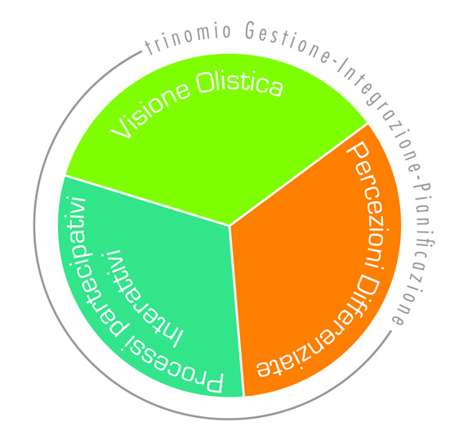
The theme of rural development considers the Complexity as one of the key factors which have a positive impact on the territories. A holistic view is a key condition focusing on the theme of complexity which is the heart of RURALSCAPES project. Rural development is implemented through different ecosystems, both "classical", such as the mountain and the valley, and"others"ecosystems, such as social and economic. The concept of « System of ecosystems »is the basis of the work strategy as well as the planning of RURALSCAPESproject and local actions, basing everything on Complexity Theory. The territory is the context where actions will take place, it is necessarythe assessment of the landscapes for better understand this context.It is necessary to make a qualitative leap in the analysis of the landascapes’ studies, through an attentive analysis of the cultural and economic structures. New computer technologies can help us in this task, through the creationof an information system for a knowledge support to the integrated and sharedmanagement of rural landscapes.

Another methodological assumption of RURALSCAPES is based on "different perceptions" which are divided in two types of knowledge: the technical and the local one. Technical knowledge concerns persons who have a background of different gathered knowledge and several scientific referencesclosely related to the theme of rural development such as: town planners, architects, anthropologists, agronomists, economists.
Nevertheless, the technical knowledgeare only a part of reality and they are not properly taken into account by local people which are users of the great heritage of rural areas. For the developmentof RURALSCAPES’ project t is also necessary to take into accountdifferent types of local knwledgewhichhavetheir personal interpretations about the them of the project.

On the one hand, the technical knowledge analyze the context and identify the dynamics of the territory, giving a relatively homogenous framework in terms of needs and potential. On the other hand, local knowledge identify the salient features of the territory, highlighting the points raised during studies and turning them in key points of the project.
Last methodological assumption that underlies RURALSCAPES project is the theme of participation. In recent years , particular attention has been given tothe local community involvementwhich must be the centre of planning process and cultural identity. These issues are based on the Cooperation Agreements signed during the 1990s (Conference the United Nations on Environment and Development - UNCED - agenda 21, Aarhus Convention etc ..).

Even today, despite numerous conventions, international and national laws, they do not go further than meredebates: there are few instruments which can help people in shaping their own future. There is usually a top-down approach concerning urban and architectural projects as weel as in the decision-making process. This top-down approach is due to the reduced deadlines for the execution of the project as well as the emergency situation byadopting extraordinary intervention measures rather than ordinary ones.It would be appropriate to reconsiderthe issue of "time" because "It is the time you have wasted for your rose that makes your rose so important ". Maybe we should tame each other and allow ourselves to be tamed,quoting Saint-Exupéry one more time, gainingmore influence in the decision-making process of the rural development and in the transformation of the territory. Most of the world’s inhabitants do not have the knowledge, both technical and intellectual, for acting in those decision-making processes which organize, plan, influence our daily life and, above all, our future. It might perhaps be said that ,ntill now, has tried to activate participatory processes through multiple instruments and methodologies, suche as Forum, public meetings etc. All these events have in common the lack of an essential factor: the continuity over time. Cersosimo says that there are three key words in order to activate and develop the participatory process: know-how, expertise and patience. To do so we have to reviewthe issue of the time. You can’t activate a participatory process on the basis of a project or call : it must be a continuous process, with diversified activities ranging from education in primary schools to the management of the strategic plans.

The European Union has tried to face these problems with the implementation of several community programs on the concept of governance, participation and democracy. Among these, not least, there is also the European Landscape Convention (ELC). These activities require a fundamental element: the continuity over time. Continuity becomes one of the keywords that must be taken into account for the renewal of the participatory processes: no more processes, but lifestyles.

Reasons for the initiation of the cooperation activity
Specific motivation regarding the development of the area ofLAG BaTiR
With the purpose to strengthen the processes of local sustainable development, LAG BaTiR has deemed useful and effective to start the cooperation with other FLAGs with similar problems or complementary experiences exchanging know-how and creating synergies needed to implement common actions, for the benefit of all the territories involved.
The territorial analysis carried out by the technical group of the Local Action Group (FLAG) BaTiR in order to draft the LAP (Local Action Plan) concerning the coastal areas on theTyrrhenian sea by Reggio Calabria has evidenced the problems and potential of the land, allowing to identify the primary objectives of the integrated strategy to be implemented (in order to minimise weaknesses) and the endogenous resources (strengths) on which to build on.A short synthesis is shown in the SWOT analysis.

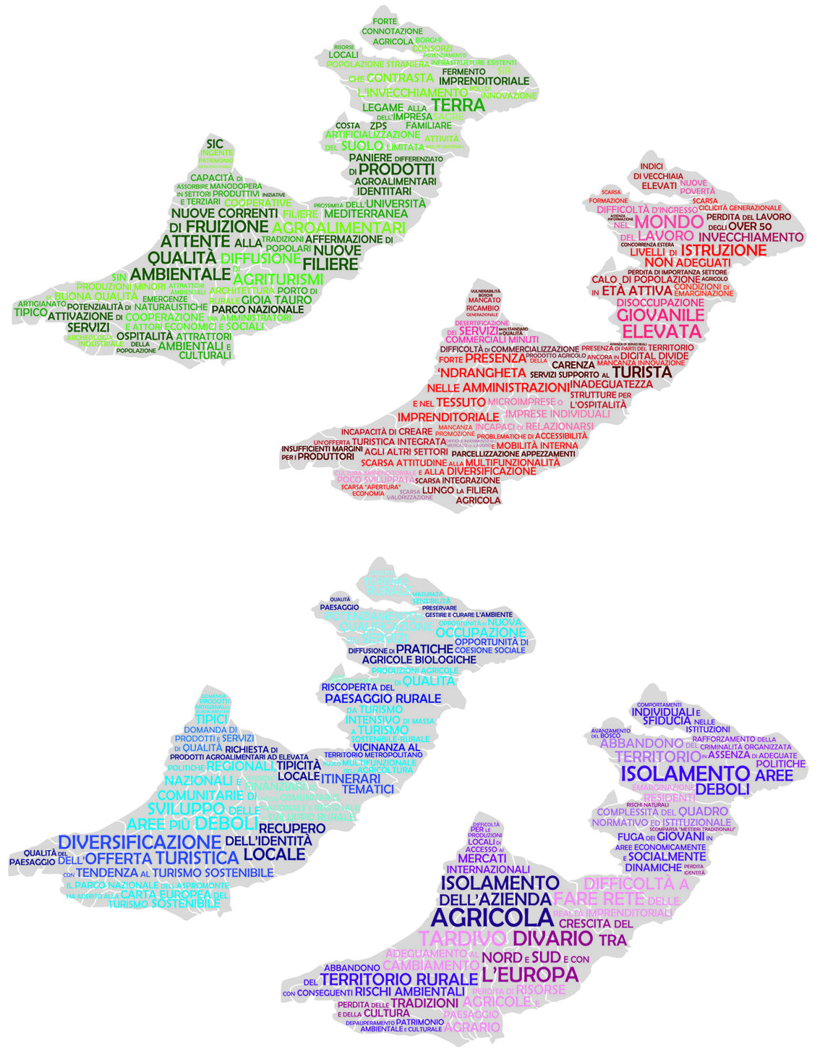.

Reasons behind the choice of the cooperation theme.
The choice of the integrated management of rural areas as theme for RuralScapes cooperation project, is carried out from the widespread awareness, both at European and global level, of the needs of rural areas to have a knowledge system. The aim of this knowledge system is to safeguard, of the one part, the uniqueness of these territories together with the wealth of the landscapes, cultural and natural heritage; of the other part, highlighting their potential in terms of tourism and food production use. For the cooperation constitute a real added value for the PAL integrated strategy, it was necessary to identify the need for cooperation, or the application (development needs) and supply (experience and expertise to share) of the territory.

The first steps of the said analysis of the rural territory covered by the LAG have highlighted a series of problems connected to the delay in development which is a prominent feature of the area, as well as commendable strengths, both under the economical, social and environmental point of view, which represented the need for cooperation in this area, the departure themes for the research of potential partners establishing joint initiatives. In the light of past experience as a LAG Batir in the cooperation field, LAG Batir LAG and its partners believe that the RURALSCAPES project will enable to rural areas,together with local actors to acquire new ideas and methodologies to promote an integrated development within their territories, experimenting new solutions and methods, sharing skills and resources, facilitate mutual knowledge and circulation of information, therefore obtaining tangible and intangible outcomes from the dissemination of good practices and suggestions for the public decision-makers.In identifying the strategic goals and objectives we have tried to be consistent with the priority needs expressed by interactive participatory process and directly related to the Project Transnational Cooperation that are evident in Table 50 of the Local Action Plan, represented below.

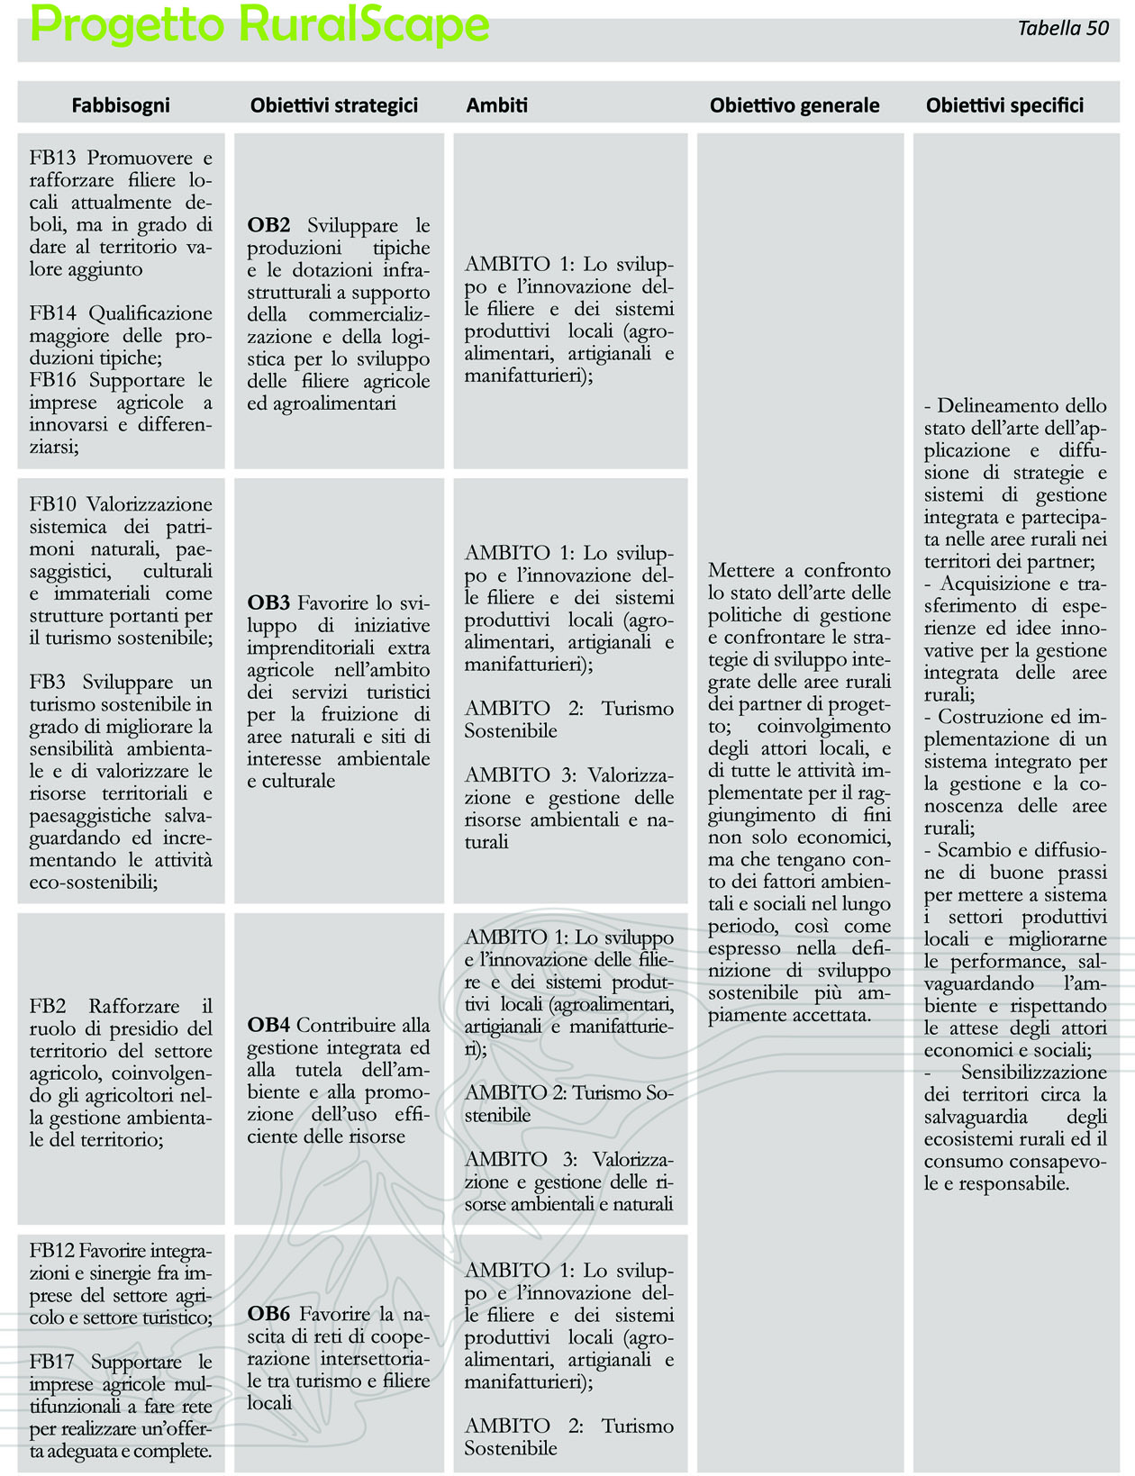

Obiettivi generali e specifici del progetto RURALSCAPES
The overall objective is to compare the state of current management policies as well as the integrated development strategies of project partners regarding rural areas of the project partner, the involvement of local actors as well as all the activities implemented in order to reach objectives. This does not only take into account economic aspects, but also environmental and social factors on a long-term basis, as expressed in a largely accepted definition of sustainable development. The exchange of good practises and know-how will aim to spread ideas and suggestions among local actors, both public and private, in order to introduce inter-sector and intra-sector integrated actions in the management of rural areas including: sustainable tourism, management of cultural and natural heritage, widespread hospitality, social inclusion, supply chains, rehabilitation of the environment and of the cultural heritage connected with therural tradition and hidentity.

The cooperation project RuralScape is aiming specifically to reach the following general objectives:

• Improving capacity building, seen as “ability to manage one's own resources”: cooperation with experienced partners can allow a significant amount of knowledge transfer. This knowledge, adapted to the needs of each territory, can be a driving force for local development.
- Reaching the critical mass needed to face important intervention to help the development of the area, joining economic and human resources.
- Acquiring skills and professionalism at different levels, improving the amount of knowledge present locally.
- Transferring and acquiring good practises and know-how on the subject of sustainable and integrated development.
Other specific objectives that are going to pursue include:

Describing the state of current implementation and dissemination ofthe integrated and shared management of rural landscapes’ project in the partner territories;
- Acquiring and transferring experiences and innovative ideas for integrated rural areas management;
- Exchanging and spreading good practises in order to update local productive sector as well as improving their performance, protecting the environment and satisfying the expectations of economic and social actors;
-Raising awareness locally on the protection of rural ecosystem as well as sustainable consumption and consumer awareness;

Operative objectives
The operational objectives of the RURALSCAPES project are:
- carrying out study visits on the territories of partner LAGs, in order to improve mutual knowledge, to exchange experiences and good practises;
- the creation of a book of guidelines for the enhancement of an integrated and shared rural management;
- organising information and communication events focussing on the aims and results of the project.

Continuity, complementarity and/or integration ofRURALSCAPESproject with other completed or on-going cooperation projects which did not concern the LAGBaTiR area
The theme object of RURALSCAPES, integrated and shared rural areas management, appears in continuity with all the general objectives and many specific objectives of the governances working on the LAG territories, specifically in their aim to promote an harmonic development, which doesn't only account for productive targets, but also focuses on environment and on the members of society that use these territories, as well as promoting cooperation amongst local actors (for example, through the creation of networks of actors and associations).
The main theme of RURALSCAPES is coherent with the PAL strategy "Tyrrhenian Itinerary: for Conscious and Responsible for the Integrated Development of the Tyrrhenian" by Batir GALthat is ‘improvement of the quality of life in rural areas’ and with the general objective concerning the 'Enhancement of environmental, cultural and social resources present in the territory, finalised to the definition of a rural system as a factor of environmentally sustainable development in the area’. It is especially coherent with the specific objective n.4: "Contributing to the integrated management and protection of the environment and promoting resource efficiency" and with the strategic objective 6 "Encouraging the creation of cross-sectoral cooperation networks between tourism and local supply chains."The upgrading of the territory and of the landscape includes the promotion of productive and leisure activities as well as the protection of the environment and of the cultural traditions that shaped the identity and the history of these places:also the integrated rural areas management aims to upgrade and promote the places and their identity; in this sense, RURALSCAPES is in continuity with the cooperation projects “LANDsARE” in which the LAG BaTiR is involved (through PSL Aulinas), with LAG Oglio Po Terre D’Acqua as lead partner.

Pre-development activities
The pre-development activities have taken place simultaneously with the drafting of the LAG BaTiR LAP (2016):
- the territorial analysis carried out by the technical-scientific group has highlighted the need for cooperation in the territory;
- the choice of the theme of RURALSCAPES has been substantiated by the presence of specific studies on the subject of integrated management of the rural areas and its evolution;
- the management of the LAGs has expressed its approval regarding the implementation of the cooperation activities;
- the proposal of cooperation addressed several European LAGs, both through direct (phone and mail) contact and through the publication of the notice on the relevantRural Network website (http://www.reterurale.it/flex/cm/pages/ServeBLOB.php/L/IT/IDPagina/16185) and also on ENRC website (http://enrd.ec.europa.eu/leader-clld/partner-search_en).

Description of expected activities
The project is divided in two sections: the first section contains a description of the activities that are common to all partners, and coordinated by the convener (LAG BaTiR), whilst in section II the activities that each LAG will carry out within its territory are listed.
SECTION I
Activity 0 – Planning and coordination of the project
0.1 Drafting of the cooperation report
0.2 Creation and formalisation of the cooperation partnership
0.3 Coordination and management

Target group: Project partners
Responsibilities of the convener LAG: coordination of common activities, monitoring and final reporting on these, creation of intermediate reports and writing a final project report.

The products of Activity 0 will be:
- Writing a project dossier
- An expression of interests for each FLAG partner, a Cooperation Agreement
- A Timescale plan and a financial activity plan
- Creation of a Steering Committee
- Minutes of each Cooperation meeting
- Semi-annual Project Repor
t- Creation of a webpage on the project on the LAG website

Activity 1 - Study visits for the exchange of experiences and good practises
1.1 Preparing the material for the exchange of experiences amongst the partners (presentation of the territories, collection of possible good practises)
1.2 Study visits (at least 7), to be developed on themes chosen by the Hosting Partner:integrated and shared management of rural landscapes, best practices related to the main theme RURALSCAPES, sustainable tourism, creating EGCC, sustainable production etc.
Target group: Project partners, local actors from the areas involved, who will take part in the study visits.
Responsibilities of the convener LAG: Coordination of common activities, collection of shared material, preparation of the reports of the study visits, monitoring, reporting of expenses of the activities funded:
The products of Activity 1 will be:
- n. 7 study visits
- 1 folder of material to share among the partners
- n. 7 reports of the visits

Activity 2 - Creation of a book of guidelines on integrated rural areas management
2.1 Selection of an expert responsible for drafting the book
2.2 Collection and elaboration of the guidelines
2.3 Dissemination: organisation of informative conferences, press (in English and Italian) and dissemination of the book.
Target group: Project Partners, one expert on matters of sustainable development, local actors from the interested areas as well as the widest possible public audience, participating in the conferences.
Responsibilities of the convener LAG: Coordination of common activities, collection of shared material, preparation of the reports of the study visits, monitoring, reporting of expenses of the activities funded.
The products of Activity 2 will be:
- n. 1 contracting an expert responsible for drafting the book,
- 1 Book of Guidelines on integrated coastal management
- n. 2 Conferences on themes regarding the project

Project indicators
Indicators | Unit of measurement | Unit of measurement
Output indicators
Partner
Of whichLAG | number
Of which Partner no LAG | number
 | number
States involved (for transnational projects) | number | (Italy, Spain, Scotland, Czeck Rep., etc...)
Common structure | number | 1 partnership
Network among local operators | number | 1 page on each LAG’s website
Common produce | number | 1 book of guidelines
Reporting of expenses | number | 1 reporting of expenses
Indicators of the project activities
Activity | Activity Indicator | Provisional value
0.1 Drafting of the cooperation file | Approved project file | 1
0.2 Creation and formalisation of the cooperation partnership | Cooperation partnership  Steering Committee | 1  1
 | Expression of interest | 1 for each partner
 | Cooperation Agreement | 1
- Coordination and management | Time schedule | 1
 | Financial plan of activities | 1
 | Minutes of each cooperation meeting | 7
 | Project Reports (PR) | 10
 | Creation of a webpage on the project on the LAG website | 1 for each partner’s website
1.1 Preparation of the material for the exchange of experiences amongst the partners | Multimedia file of material in electronic format | 1
1.2 Study visits | Study visits at the partners’ sites | 7
 | Visit Reports (VR) | 7
2.1 Selection of an expert responsible for drafting the book | Contracting of an expert | 1
2.2 Collection and elaboration of the guidelines | Drafts attached to the project reports | 2
2.3 Dissemination: organisation of informative conferences, article press (in English and Italian) and publication of the book. | Book of Guidelines on integrated coastal management | 1
 | Conferences on themes regarding the project | 1-2
Results indicators (short-term impacts)
Project activities | Impact | Indicator
Activity 0 – Planning and coordination of the project | Capital relation created | 1 cooperation partnership
Activity 1 - Study visits for the exchange of experiences and good practises | Experiences and good practices ICZM exchanged | ≥ 9 exchanged experiences, 5000 visits of the webpage of the project, 200 people involved through conferences
Activity 2 – Creation of a book of guidelines on integrated rural areas management | Dissemination of guidelines for the implementation of the ICZM | 1 book (200 copies distributed) in electronic or in paper form)

6. METHODS AND PROCEDURE FOR THE IMPLEMENTATION OF THE PROJECT
Legal and management form
The legal and management forms are agreed by the partners in the Cooperation Agreement.

Implementation methods
Implementation methods | Activity | Partner in charge
Operated directly | Activity 0 | The lead partner LAG is responsible for implementing the project, concerning actions of its relevance and those delegated by the partners, with regards to choice of supplies, selection of experts, planning and developing activities, creation of products after previous consultation with the steering committee
 | Activity 1
 | Activity 2

ORGANISATIONAL ASPECTS
Work planning
Project start date: September 2017
Project end date:December 2021
Timescale
Activity | 2017 |  | 2018 |  | 2019 |  | 2020 |  | 2021
 | I  Semester | II Semester | I  Semester | II Semester | I  Semester | II Semester | I Semester | II Semester | I Semester | II Semester
0.1 Drafting of cooperation proposal
0.2 Creation and formalisation of the cooperation partnership (and of the steering committee)
0.3 Coordination and management
1.1 Preparation of the material for the exchange of experiences amongst the partners
1.2 Study visits
2.1 Selection of an expert responsible for drafting the book (guide lines)
2.2 Collection of experiences and elaboration of the guidelines
2.3 Dissemination: web page on partner’s web site, information conferences, articles press and publication of the book.
Selected methods for carrying out organisational and directive tasks
The LAG BaTiR, as a lead partner, has a role of coordination and supervision of project activities, with the support of the Steering Committee (SC), according to what is established in the Cooperation Agreement.
Project organisational structure
In addition to following the directives of the Managing Authority referring to the formalities required to carry out the cooperation activities, the cooperation partnership will be organised according to ‘management bodies’:
Lead Partner: coordinates and manages activities ensuring the best implementation of the Project. Heads the Steering Committee formed by representatives of all the Partners. Roles and tasks of the Lead Partner aredetailed in the Cooperation Agreement. The lead partner LAG will also be responsible for the selection of scientific advisors responsible for drafting the Guidelines.
Technical-scientific group for coordination and management: this group is identified in the organisational structure of the lead partner, it comprises professionals with experience in the field of integrated development and it has the function of technical secretariat, aiming to ensure the correct management of common activities, circulation of information amongst the partners and communication activities, facilitating also the communication with the different Managing Authorities.
Each partner LAG is responsible for carrying out the local activities as well as reporting expenses incurred for implementing these activities, and is a referent for its own local partnership as well as spokesperson for the development needs of its territory.
The task of each LAG is to direct, coordinate, monitor and evaluate the project activities and the participation of local partners. Each LAG organises autonomously the methods of delivery for their working group, but they commit to respecting the common RURALSCAPES engagements.
A detailed program of activities will be agreed during the first meeting of the Steering Committee, when the final cooperation agreement will be signed, a binding document which will mark the creation of the cooperation partnership.

8. FINANCIAL ASPECTS
Financial plan of the project
Nome GAL | % Finanziamento pubblico | % Finanziamento privato | Pre-sviluppo | Azioni Comuni |  | Azioni locali | Total cost
 |  |  |  | Funzionamento della struttura comune e supporto tecnico all’attuazione del progetto | Realizzazione delle azioni comuni | Attività pianificate nel progetto locale (costi)
LAG BaTiR | 100% | 0% | 27000 | 27000 | 108000 | 108000 | 270.000,00
TOTALI

Expense timescale
Project start date: 2017
Project end date: 2021
LAG BaTiR | I anno | II anno | III anno | IV anno | V anno
Activity 0 | 10% | 5% | 5%
Activity 1 | 5% | 10% | 10% | 5% | 5%
Activity 2 |  | 10% | 10% | 10% | 15%
Total GAL BaTiR | 15% | 25% | 25% | 15% | 20%
GAl…..
Activity 0
Activity 1
Activity 2
Total GAL…..
GAL…..

Sustainability of activities
The sustainability of RURALSCAPES occurs on two levels:

1. At the regional level the project will allow the acquisition of skills and experience in areas that face the same challenges in integrated management and development of rural areas and will provide a wealth of knowledge and know-how expendable in the long term, beyond the termination of the project.

2. At the transnational level, the cooperation started with the described project will lead to the creation of a relational capital, which can be a starting point for future collaborations for further planning and cooperation. In addition, the cross-cutting nature of the activity, thanks to the participation of different professionals and foreign partners, will be useful to a wide audience in the European rural zones.

