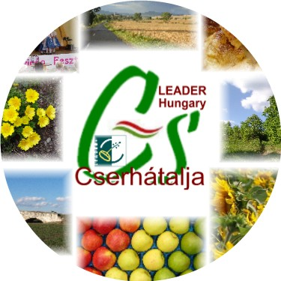 | Cserhátalja LEADER Helyi Akciócsoport Cserhatalja LEADER LAG

REGISTRATION FORM
2nd LEADER Cooperation Forum, 16-18 September 2010, Kozard
(please return before 5 September 2010 by email to hajas@cserhatalja.eu or fax to +36-32-491076)

Name of LAG or Partner Organization:

(IMPORTANT: If your farmers, artists intend to participate with products, we need your LAG’s logo in jpeg or gif, png file format)
Address of LAG or Partner Organization, email, telephone:

Contact person name, email, telephone

Number of persons registered, including indication for room sharing):
Arrival date, time:
Mode of travel:
Cooperation project title, project idea:

Suggested other LAGs to be invited: Name, E-mail, Contact person
Please mark programme options (underline or circle)
16 September: Project meeting Yes / No
17 September: Group meeting in morning Yes / No, Option 1, 2, 3, 4
18 September: Indicate special request
19 September: Time of departure

Date: Name/Signature

