Detailed Information: http://www2.unccd.int/news-events/2017-world-day-combat-desertification-2017wdcd

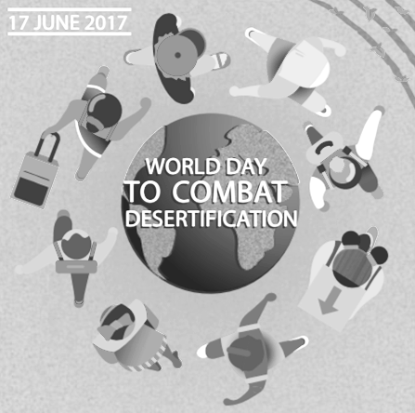

SOCIAL MEDIA GUIDANCE

Our Land. Our Home. Our Future

#2017WDCD

Suggested General Messages

**CARD 1: Fight or Flight**

Facebook / Instagram:

1 in 5 youth, aged 15-24 years, is willing to migrate to another country. Those in poorer countries even more willing, for a chance to lift themselves out of poverty. Let's restore degraded land that brings jobs and open opportunities for all! #2017WDCD @UNCCD

Twitter:

Let’s give young, rural populations better choices & options. Restoring degraded makes the land & life viable for young people. #2017WDCD

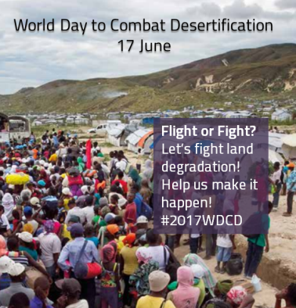

**CARD 2: Productive Land**

Facebook / Instagram:

Is there anything that last forever? A well- managed land. Find out how “[Rediscovery of Humanity](http://bit.ly/2rIFWoL)” changes the vicious circle of degrade-abandon- migrate to the virtuous circle of protect-sustain-restore. Let’s help people back to their homes. #2017WDCD

Twitter:

With the right type of investments in land, rural infrastructure and skills development, the future can be bright. #2017WDCD @UNCCD

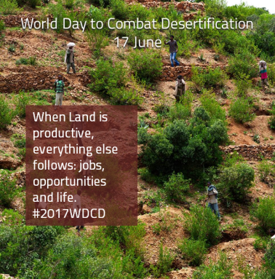

Suggested General Messages

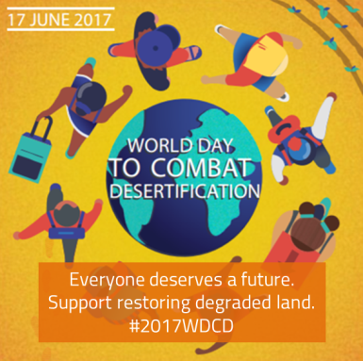

**CARD 3: Our Land. Our Home. Our Future**

Facebook / Instagram:

Hope can be given back to entire communities by restoring land they depend on. But How do you do it? Check [here](http://knowledge.unccd.int/topics/sustainable-land-management-slm). #2017WDCD

Twitter:

Let us give young people and communities the chance to bring that natural capital back to life and into production. #2017WDCD @UNCCD

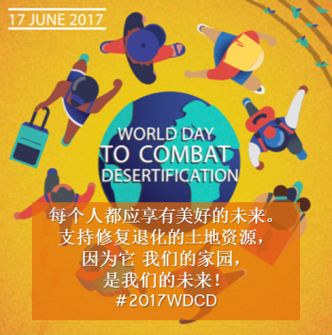

**CARD 4: 我们的土地 我们的家园 我们的未来**

微波:

让我们提供给青少年一个机会，让自然资源重新注入新生，产出更广阔的价值 #2017WDCD #世界防治荒漠化及干旱日

Social Media Links

[The World Day to Combat Desertification (17 June)](http://www2.unccd.int/news-events/2017-world-day-combat-desertification-2017wdcd)

[Support our](https://www.thunderclap.it/projects/57594-our-land-our-home-our-future)

[World Day to Combat Desertification Campaign #2017WDCD](https://www.thunderclap.it/projects/57594-our-land-our-home-our-future)

[Facebook](http://facebook.com/unccd)  @UNCCD

[Twitter](https://twitter.com/unccd) @unccd

[Weibo @联合国防治荒漠化公约](http://www.weibo.com/p/1001063315932722/home?from=page_100106&mod=TAB&is_all=1)

[Instagram](https://www.instagram.com/unccd/) @unccd