CLLD-LEADER, LOCAL AND TRANSNATIONAL COOPERATION
REGIONAL DEVELOPMENT COMPANY OF PARNONAS

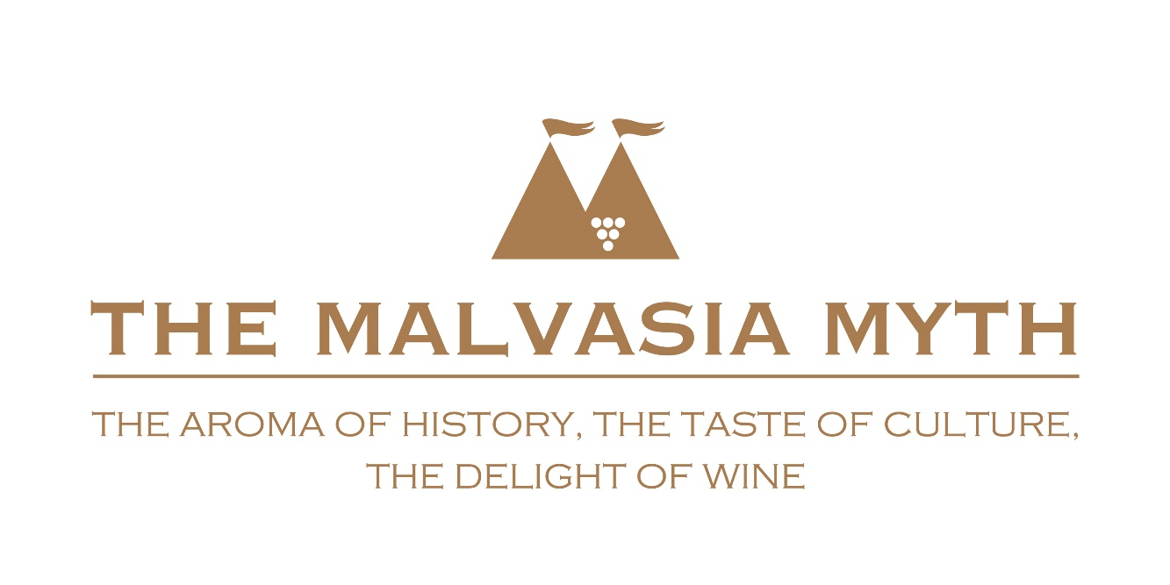

TRANSNATIONAL COOPERATION PROPOSAL
«MALVASIA MYTH»

Proposal for  CLLD Transnational cooperation project | 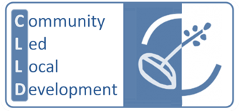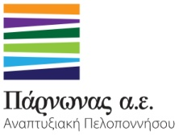

Content
Action plan «The Malvasia myth» 2
1. Purpose and objectives of cooperation 2
2. Search for potential partners 2
3. Documentation 2
4. Analysis of actions 3
5. Resources allocated for the organization of cooperation 5
6. Expected results 5
7. Action already undertaken 6
Attracting attention 6
8. Proposed method of implementation of the work plan 6

Transnational cooperation project «The Malvasia myth»

1. Purpose and objectives of Cooperation
(Eg. critical mass search, complementary search, knowledge transfer, etc.).

- Utilization of possible historical name of Malvasia wine
- Utilization of viniculture and Malvasia wine production in many Mediterranean areas for networking and cooperation between them
- Find at least 5 partners from various production areas of Malvasia, including educational and academic institutions, professional bodies etc.

2. Search for potential partners
(Selection criteria, the partner’s characteristics etc.).

The partner selection criteria are:
- the production of Malvasia wine or exemption from existing Malvasia varieties in LAG areas
- the feasibility of actions within the framework of cooperation
- the relevant prior experience of participation in transnational partnerships

3. Documentation
In relation to the characteristics of the region and its strategic goals.

The study of the existing situation in the intervention area of the Development Company of Parnonas indicates that the wine industry is one of the most important for the agricultural economy of the region as it represents an essential growth factor. One of the most famous wines produced in the Peloponnese area is the wine of Malvasia. But its history, as unequivocally true to its name, starts from Monemvasia. From 2011 onwards, the Greek wine law has allowed the myth of Malvasia wine to revive. From the three designations of origin established then, the first established was that of the PDO Monemvasia-Malvasia and the first modern Malvasia wine from Monemvasia is already a fact.

The production area of PDO wines Monemvasia-Malvasia extends in the agrarian region of the former municipalities of Monemvasia, Asopos, Vion and Molaon of Laconia. The use of the comparative advantages of the primary sector and in particular in the wine sector, through product manufacturing, promotion of innovation, promotion tools, etc. is an imperative to enhance the export activity, to create jobs and to stimulate the local economy.
Also, the vine cultivation and the various composition of the Peloponnesian vineyards, the quality of the wine and the tasty character, marketing, pricing policy, education, research, product development (R & D), the legislation and institutions all of those constitute "success factors" and needs to be examined.
Moreover, the findings of the existing situation in the intervention area of the Regional Development Company of Parnonas shows that the most important of tertiary industry is the tourism. The geomorphology and infrastructure of Southeast Peloponnese area make it a destination appropriate for all seasons. But so far the comparative advantages of the region are not sufficiently exploited to highlight the tourist identity of eastern Peloponnese, which could be a strategic tool in today's competitive environment.
The implementation of the Transnational Project will contribute to the definition and cohesion of wine-tourism product of the region to benchmark and boost the wine tourism in the total of Peloponnese area.
The wine tourism is a growth opportunity that should be exploited, since it has all the dynamic and qualitative data that allow the interconnection of the tourism economy and culture, in terms of real development, compatible with the natural and cultural balance in the places of destinations. The wine tourism in general can help:

- in strengthening the family income through tourism activities, thus raising the economic level of the region
- to sustain local population in the areas of intervention
- in the use and preservation of local cultural heritage
- in dissemination of local products beyond the boundaries of the Peloponnese.

The Cooperation Plan actions are consistent with the following thematic directions of Measure
19 of the RDP 2014-2020 concerning:
- Supporting local entrepreneurship and the emergence of local identity.
- Improve the competitiveness and particularly improving the competitiveness of the agri-food sector value chain.

The interconnection of areas and economic factors.

4. Analysis of actions
to be held within the Cooperation Project

A. Planning Phase (Transnational meetings)

B. Main phase

1. Preparation, research and documentation
- Transnational project planning meeting
- General study of historical data: Research and development of bibliographic, historical, research data. Scientific substantiation of the value and the brand name Malvasia in historical time, from the start of production until the expansion and consolidation in Europe and the new productive areas in the Mediterranean.
- Specific areas of studies: Stocktaking of varieties, wineries, wines, local historical and cultural elements and various other elements of the region and its wine producing identity.
- Development of specifications: Specifications and guidelines for the creation of branding and network tools concerning a) Creation and website operation, b) Writing texts and material collected by partners, c) Key professional education routes, d) Main Event axes and festivals etc.
2. Δημιουργία διεθνούς brand Malvasia
- Branding Malvasia: Concept, story and brand development. Creation of individual elements (logo, graphic, slogan, texts, etc.) Defining identity of the project. Adjusting material for various applications, print and electronic.
- Creation of audiovisual material: (Creation of audiovisual material, video, photo etc.) for all the regions. Collection, assessment and presentation of all necessary data.
- Electronic infrastructure: Design of multilingual website presenting elements of history and wine production, wine and other complementary wine businesses and related products, tourist information production areas etc. Designing mobile applications( mobile apps ).
- Marketing plan: Design and implementation of the campaign (online viewing, media promotion, participation in activities and reports, etc.). General and local implementation. Focus on the promotion of thematic tourism packages.

- Entrepreneurs Training: Local training in using the brand. Configuration of educational program depending on local conditions. How to accept the brand and its inclusion in products and campaigns of the enterprise.

3. Setting up of Malvasia network
- The «Malvasia» Network Strategy and Action Plan: Development of Action Plan and Strategy for the establishment and operation of the Network.
- Network / entity Recommendation: Implement the necessary actions for establishing the network. Create statutes. Creating of formal body. Legal and technical services.

4. Organization and upgrading events and institutions
Designing and implementation of new events and strengthening and upgrading the existing network of events and wine festivals and historical interest in the region of Malvasia.
Monemvasia Events: Design and implementation of a new festival. It will include promotion of the Medieval Castle of Monemvasia, promotion of vineyards in the region, Malvasia wine tastings, cultural events and Malvasia Congress
• Events Partner 2: Design and implementation or upgrade festival or conference.
• Events Partner 3: Design and implementation or upgrade festival or conference.
• Events Partner 4: Design and implementation or upgrade festival or conference.
• Events Partner 5: Design and implementation or upgrade festival or conference.

5. Thematic tourism development
- Creation of tourist packages: Design and creation of thematic tourist packages for the Network areas. Thematic tourism development and wine tourism. Formulation and pricing of the proposals, creating material, cooperation and tourism business agreements, promoting to tour operators in different countries.
- Participation in partner events: Participation of winemakers, tourism professionals, artists, etc.
6. Expenditure of coordination actions.
- Expenditure of coordination actions.
- Consulting services for the support and coordination of the project.

5. Resources that will be allocated for the organization of cooperation
(Human resources, financial resources).

Human resources

For the implementation of the Plan the following partnerships will be ensured:
- With executives from the permanent staff, full or part time. Partial / casual employment, depending on the progress and implementation requirements,
- Fixed external partners, with experience in specific projects. Specialized external consultants where necessary during implementation.
- The lead partner experience in coordination and implementation of many similar projects to ensure the smooth and effective implementation of the Plan, through the selection and coordination of appropriate staff and partners.

Financial resources – INDICATIVE!

The details of a plan are as follows:
Expected number of partners: 5 (4 minimum)
Total estimated budget: 360.000,00 € for 5 partners
Average budget per partner: 72.000,00 € (from 68.000.00 to 79.000.00)
Budget allocation:
A. Preparatory Phase (transnational meetings): 6.000,00€
B. Main phase: 354.000,00 €
- Preparation, research and documentation: 34.500,00 €
- Create an international brand Malvasia: 124.000,00 €
- Setting up the Malvasia network: 12.500,00 €
- Organization and upgrading events and institutions:67.000,00 €
- Thematic tourism development: 77.500,00 €
- Coordination - support:38.500,00 €

6. Expected results
the cooperation area (short term, long term).

The wine industry in Greece is already one of the most important factors in rural economy as it represents the essential factor for growth. It is a creator of employment, it boosts economy, and it adds value and helps to combat the rural exodus. Interestingly particular is the region of Peloponnese, as it has the largest vineyard wine grapes in the country (about 237,000 acres), and holds primacy in all productive sectors (number of wineries, number of produced tags, number of cylinders).

The Regional Development Company of Parnonas, in the new programming period CLLD / LEADER 2014-2020, is aiming at transnational cooperation with countries implementing local LEADER programs. The aim of this cooperation is:

- the promotion and dissemination of wine culture,
- the growing dynamic of the name and history of Malvasia brand
- the development of actions in various fields that will utilize the brand Malvasia
- the creation of income and jobs associated with the production and tourism.
- the promotion of Malvasia production areas and their specific characteristics (history, tradition, nature, gastronomy, culture)
- the creation and utilization of the network carrier of Malvasia regions to undertake more actions and coordinate efforts

7. Actions undertaken
for establishing cooperation.

- Study design and drafting transnational cooperation proposal
- Dispatching the proposal and brochure to prospective partners
- Monitoring

8. Proposed method of implementation of the work plan
The following application method is anticipated.
- Definition of coordination group.
- Set implementation rates for local actions of each partner as well as the key actions.
- Search, assessment and cooperation agreements with external specialized partners and stakeholders for the implementation of various actions of the project.
- Constant communication and update of the coordinating partner to the rest of the partners.
- Transnational partner meetings and a coordination team, in person or electronically, via internet, to evaluate the progress of implementation and taking necessary decisions.
- Review deliverables and take corrective actions where required.
- Evaluation plan

